**#Main Workflow Screenshot**

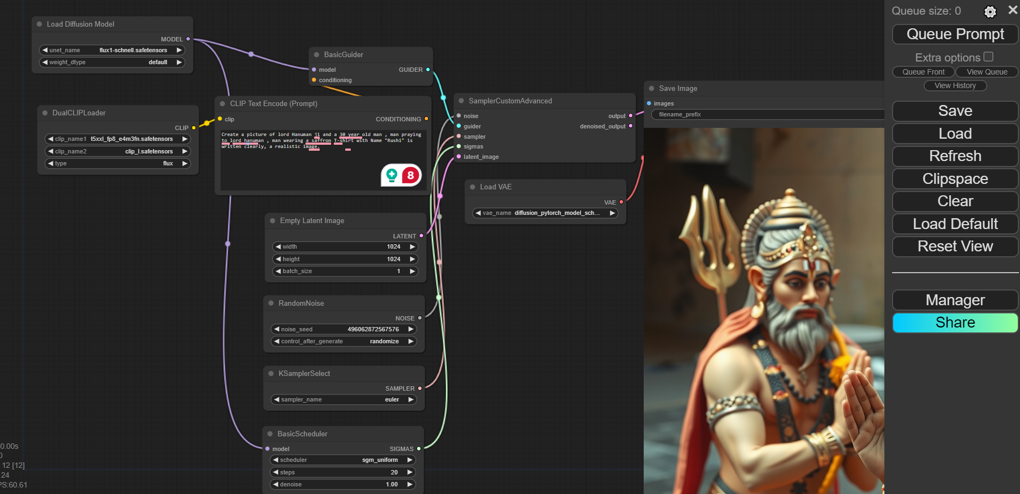

**#First Prompt**

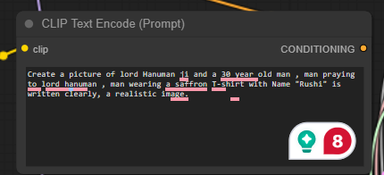

Create a picture of lord Hanuman Ji and a 30-year-old man praying to lord hanuman, man wearing a saffron T-shirt with the Name "Rushi" is written clearly, a realistic image.  
  
**# First Prompt Result**

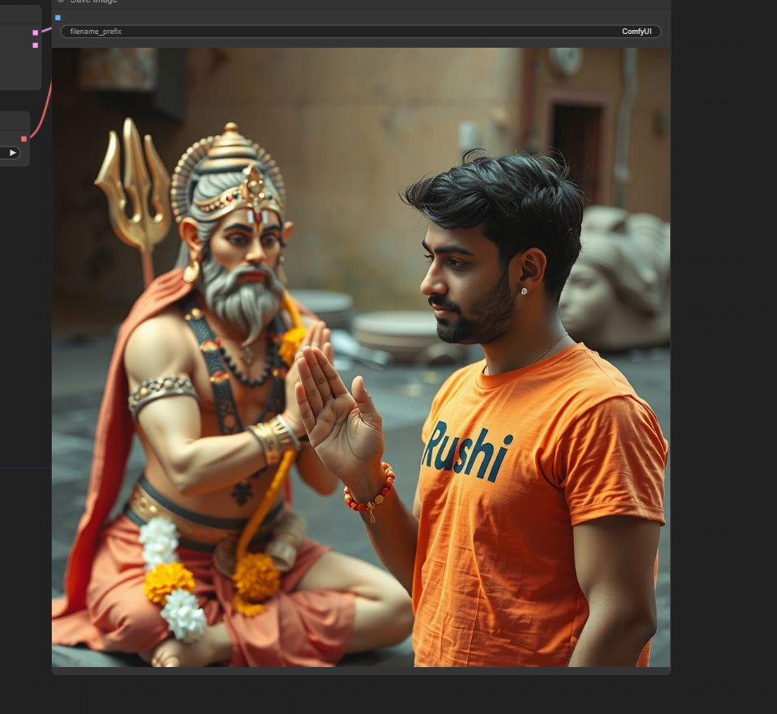

**#Second Prompt**  
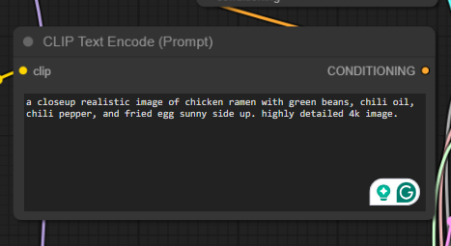  
**# Second Prompt Result 1**  
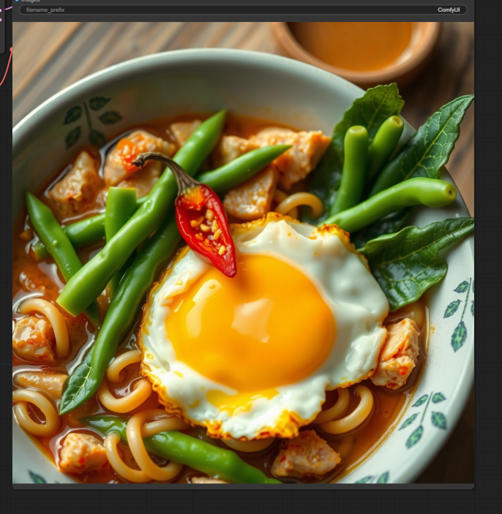

**# Second Prompt Result 2**



**# Third Prompt**

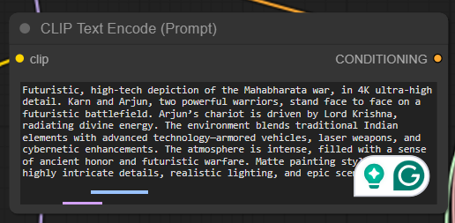

**# Third Prompt Result**  
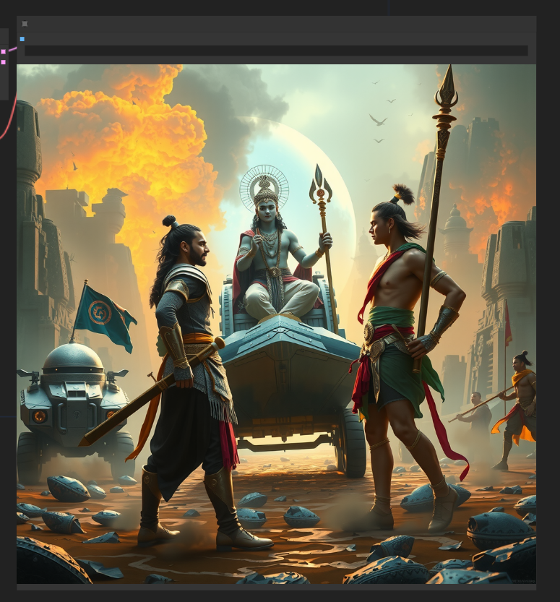

**# Fourth Prompt**

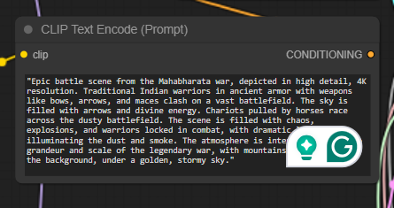

**# Fourth Prompt Result**

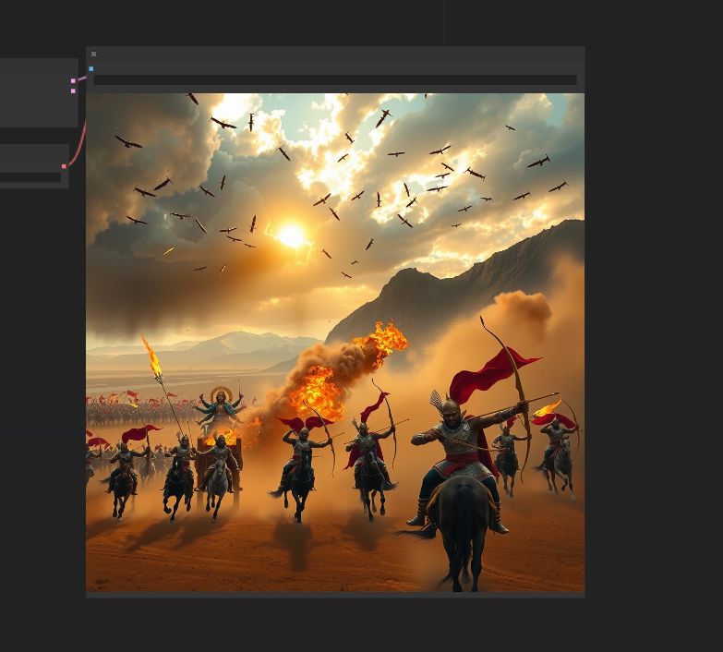  
  
**# Consol View for all the prompts**  
  
